Fog Vision for Vehicles using Computer Vision and Deep Neural Network Algorithms

Varun Totakura
UG Scholar, CSE,
Guru Nanak Institutions Technical Campus, Hyderabad, India
totakura.varun@gmail.com
ORCID: 0000-0002-5114-5205
Madhusudhana Reddy. E
Professor, CSE,
Guru Nanak Institutions Technical Campus, Hyderabad, India e_mreddy@yahoo.com
ORCID:0000-0001-5316-5798

Abstract—Low visibility is one of the leading causes of vehicle accidents on roads across the world. In foggy weather, the contrast of images grabbed by in-vehicle cameras in the visible light range is drastically degraded, which makes the current applications very sensitive to weather conditions. So, the usage of Infrared - Thermal vision camera will help to overcome those drawbacks. In this paper, we have proposed a methodology for clear vehicular visibility during the bad weather conditions for the safety of the passengers. A Deep Neural Network model i.e., a Convolutional Neural Network (CNN) model was proposed for the safety driving and auto breaking system for the vehicle. The data grabbed by the Infrared-Thermal vision camera will undergo pre-processing using the Computer Vision algorithms i.e., Gaussian Blur filters and Edge Detection and then the prediction of the objects will be processed by the proposed CNN model. The accuracy achieved by the proposed CNN model is around 96% and can be used in the real world for the auto breaking system in vehicles.
Keywords—Convolutional Neural Network, Deep Learning Model, Infrared-Thermal cameras, Gaussian blur, Canny Edge Detection, Auto Breaks, Vehicles.

Introduction
Due to the increase in the pollution the weather conditions across the world is becoming very much worse than it used to be in earlier days. As per the records the no. of accidents is increasing gradually as the time increases. For example, in 2016 the number of accidents due to fog run was around 9317 and it has increased to 11090 in the year 2017. In the night times and rainy weather conditions the situation will be even worse. Moreover, the pollution is increasing gradually over the years and has even reached the extreme levels in some of the places. Due to the increase in pollutions the visibility in the normal times also has decreased which is also becoming a reason for the accidents. To overcome this situation across the world there should be some remedy. The remedy should be cost effective and easy to install in all kind of vehicles and should be common to all. Many of the researchers across the globe has made their domain to be fog-vision as in the coming year or future the situation will be out of control due to increase in pollution and extreme weather conditions.
The usage of the Thermal-Infrared cameras will be the best option in all kind of weather condition and any time. They will detect temperature and also captures different levels of infrared light which has become the main reason for their usability. This light is invisible to the naked eye, but can be felt as heat if the intensity is high enough. All objects emit some kind of infrared radiation, and it's one of the ways that heat is transferred. And they are not harmful because everything gives off infrared radiation, and thermal imaging cameras merely detect this existing radiation (rather than emit anything).
With the combination of the data which was capture with those cameras the prediction of the action will become easier when the CNN model is used. The CNN is a deep neural network algorithm which is specially designed for the prediction and classification of the images. Due to the advantages of the CNN they are been used in various kind of applications which will help the humans to make the work easier. In this paper a CNN model is proposed which will be used to predict the action form the given image data.
This paper will clearly explain about the usage of the Thermal-Infrared cameras for the fog-vision in all the times for the vehicular drivers to assist them in their vision and also to predict the appropriate actions according if the driver is not able to make the necessary action.

Related Works
An effective method for measuring the visibility distance using a single camera placed on-board a motor vehicle was proposed by Nicolas Et Al. [1]. Based on the visibility level detected by the camera placed on the vehicle their method enables estimating the “meteorological visibility distance”. But the main drawback of their proposed model is that their model cannot run the night time or in the dark places which will be again burden for the drivers in the case of visibility.
A model which was proposed by Manish Et Al. [2] in their paper is used specifically for the aviation or the fire fighter for their visibility in the attack as the place of their attack will place a major role for a military operation. They have used deep CNN to develop their model and have also used the infrared thermal vision cameras for the data feed to their proposed deep CNN model.
In the publication of Bronte Et AL. [3], they have proposed a model using the computer vision techniques firstly for the detection of the fog in the weather around the vehicle which has the capacity to predict up to 85% accurate result. They have even mentioned about the fog-visibility by their proposed model was not up to the mark in some cases which they have mentioned in their conclusion part of their paper.
Night fog detection using the multipurpose in vehicle cameras was proposed by Romain Et Al. [4]. Their work is all about the use of simple camera for the detection or the visibility to the driver in the vehicle. They did not provide any specific algorithm or method for the detection at the night times. Their proposed methodologies were based on the Advanced Driver Assistant Systems (ADAS) algorithm.
Ankit Et Al. [5] proposed an object detection model using the night vision camera data which was converted to thermal camera image. They have used Histogram of Oriented Gradients and features from accelerated segment test algorithms were used to develop their model and achieve greater accuracy.
A deep learning model for the night-time vehicle detection using visual saliency was presented as a paper by Yingfeng Et Al. [6]. Their work was based on the ADAS algorithm and they have proposed a far-infrared image vehicle detection algorithm based on visual saliency and deep learning in which they have achieved around 92.5% accuracy with the training dataset of 6000 images.
Tthe object detection algorithm with using some of the filters was proposed by Mayank Et Al. [7] And they have mainly concentrated on the Indian roads rather than generalization to all the climates and roads. Their proposed model has achieved an accuracy of 85.28% with low light conditions.
The paper Improving Night Time Driving Safety Using Vision-Based Classification Techniques was presented by Jong Et Al. [8], in which they have used ADAS concept for their proposed method. They have also proposed upgraded Multi-Scale Retinex algorithm which was used for the improvement of the accuracy of the model when used on the night time data.
Park Et Al. [9] has presented a paper regarding the person detection using Infrared images for night time intrusion warning systems using the CNN model. Their accuracy had reached 90% in object level-detection for all kind of objects.

Problem Statement
Due to raise in the pollution and drastically changes in the weather conditions, now a day the climatic conditions are becoming very worse. At that times the fog or the mist will become a very problematic situation for the drivers of the vehicle. This could even lead to the accidents and lives of the most innocent people will be lost. As per the modern study it was proved that most of the accidents that were happed in the foggy areas are just because the drivers will not have the clear vision on the road. If this situation comes in the night times, then the situation will become even worse so to overcome this a methodology was proposed in this paper. In the proposed methodology, the Infrared – Thermal vision cameras are used to grab the data and feed to the trained CNN model for the classification for auto-breaking system. So, if there is any obstacle which is in the middle of the road then the auto breaking system will be activated and the vehicle stops to avoid accidents. Real time Infrared-Thermal vision camera data in the Audi car is as shown in figure – 1.
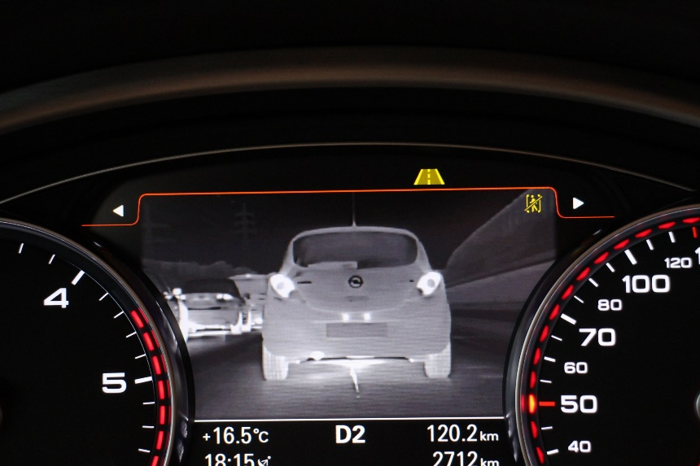
Figure – 1: Real time Infrared-Thermal vision data

Proposed Methodology
The Convolutional Neural Networks are the game changers at the times where the computer vision comes into the play. The CNNs are specifically designed for the image feed where the image will be trained using the Convolutions that were produced after the pooling in the image pixels. They have wide range of usage in the field of computer vision to provide solutions to many of the problems. Generally, a CNN will consist of multiple layers of the neurons called as convolutions and multiple phases as shown in Figure - 2. The input is the image on which the pooling algorithm is applied. The pooling is a concept in which a particular area in that image will be taken and the maximum values of the pixels will be updated in that image for the next pooling. Thus at last the image will be compressed which will become easier for the network to remember and classify according to the values.
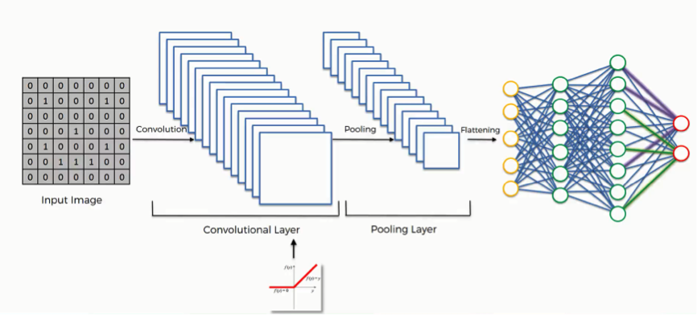 Figure – 2: CNN Example used from Super Data Science
In the same way, multiple images will undergo continuous pooling and maxing effects in various convolutional layers and finally the weights which are obtained after the process will be stored. The pooling concept is as shown in figure - 3. After certain iterations or epochs, CNN will learn and stores the weights and by storing those weights in a file we can use in various kind of applications. In some cases, the weights are used for the transfer learning technique which has a wide range of usage but here we use those weights we can predict the test data. To develop the proposed concept, we have used python as the platform to develop the CNN model for providing the solution for the problems mentioned in the problem statement phase. So, to use the advantages of the CNNs the proposed model is also designed using a CNN that will help to find accurate classified result. Each result and its accuracy will be most important as the result is used to make a decision that will save the innocent people in and out of the vehicle.
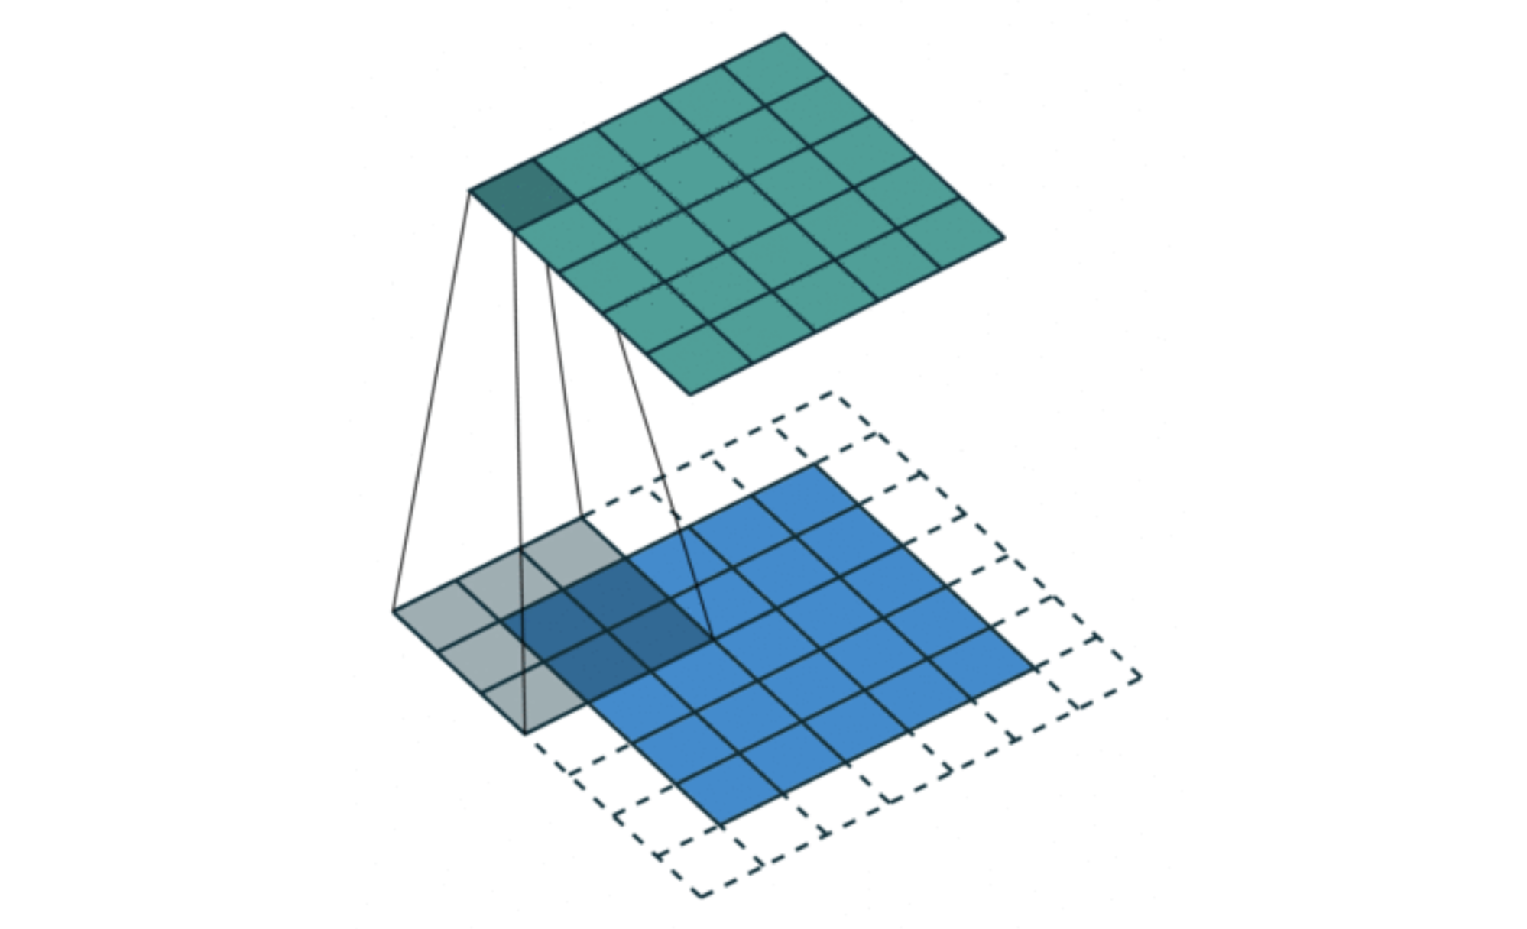 Figure – 3: Pooling Concept in CNN
The proposed methodology will work in a flow as sown in figure – 4. The pictures that were taking by the Infrared – Thermal vision cameras which were installed in the vehicle will be given after pre-processing as feed to the proposed CNN model.
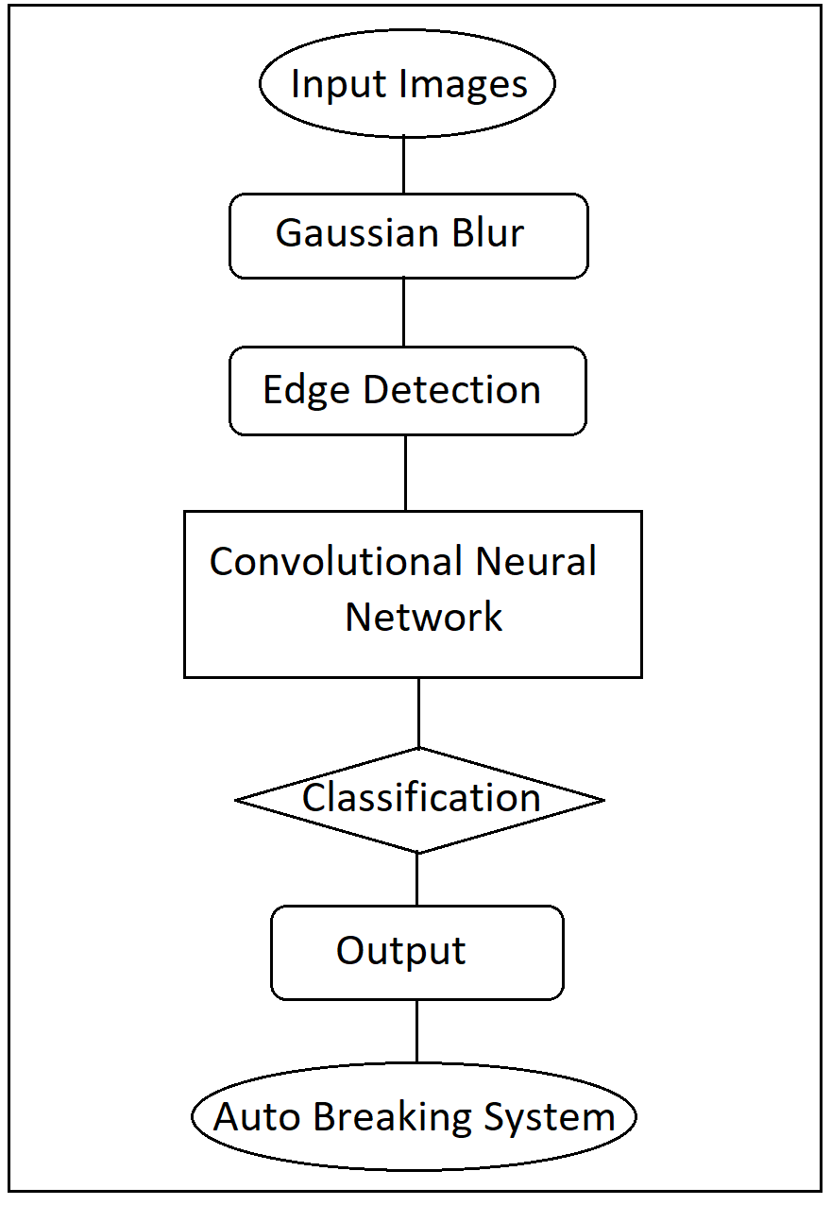
Figure – 4: Proposed System Workflow
In the pre-processing phase the images will be gone through the Gaussian blur filter which is used to normalize the pixels and produced the even images at every time. A Gaussian blur filter is a type of filter which uses Gaussian function which uses the normal distribution to normalize the data. The equation that is been used by the Gaussian blur filter for one pixel is as shown below.
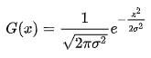
The equation of the two-dimensional data is shown below.
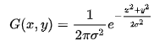

After applying the Gaussian blur filter on the camera feed data the image pixels will be normalized and looks as shown the following figures - 5, 6, 7, and 8.
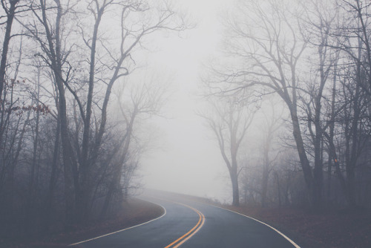
Figure – 5: Normal Image-1
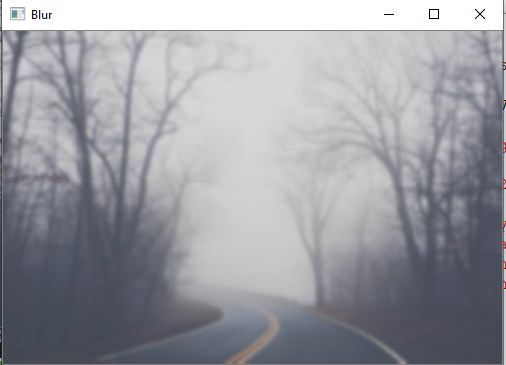
Figure – 6: Gaussian Blur on Image-1
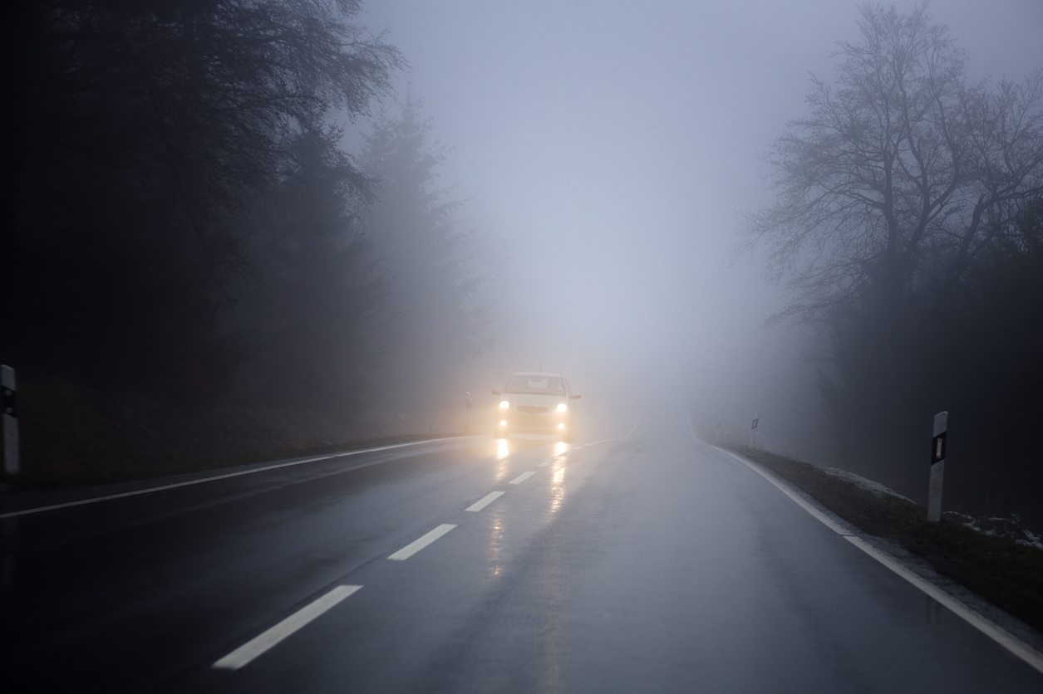
Figure – 7: Normal Image - 2
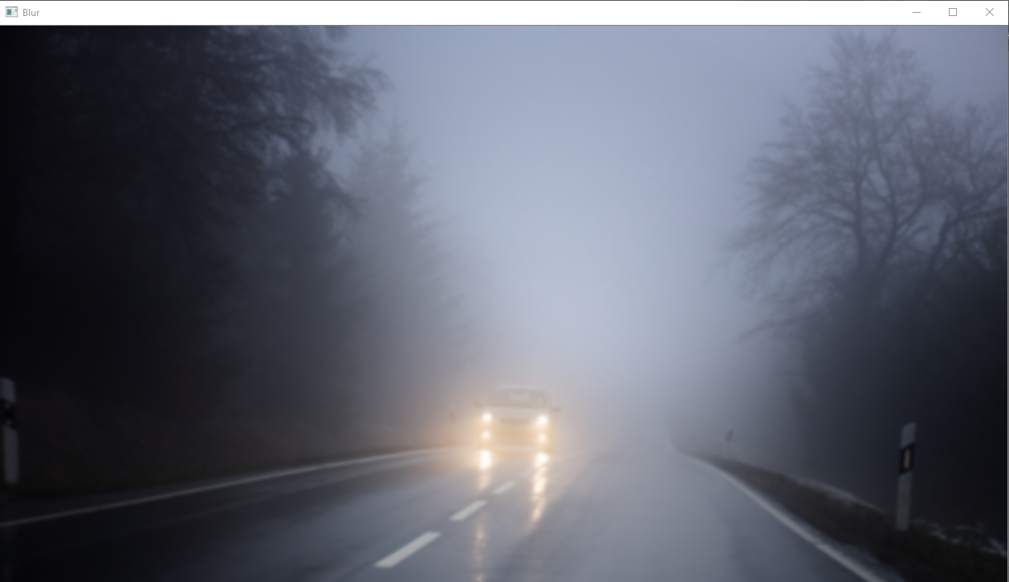 Figure – 8: Gaussian Blur on Image - 2
After the Gaussian Blur filters the data will be passed through the Canny Edge detection algorithm which is a multi-stage algorithm. The examples of the Canny edge detection algorithm were given as shown in the following figures. The original image was displayed in the left figures and the edge detected using canny algorithm is displayed in the right hand side of the following figures. In the figures – 9, 11 the images are the normal images that are taken as feed from the Infrared - Thermal camera. And the figures – 10, 12 are the images which are been produced after the canny edge detection effect.
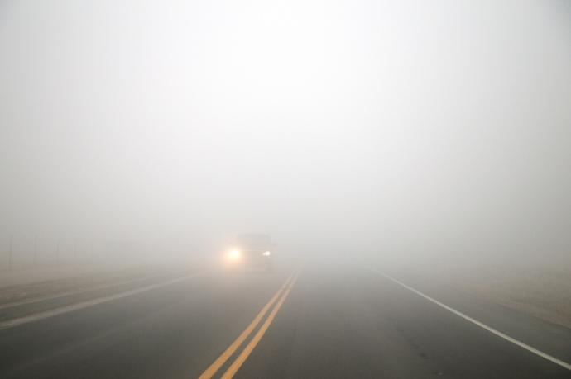
Figure – 9: Normal Image Example 1.
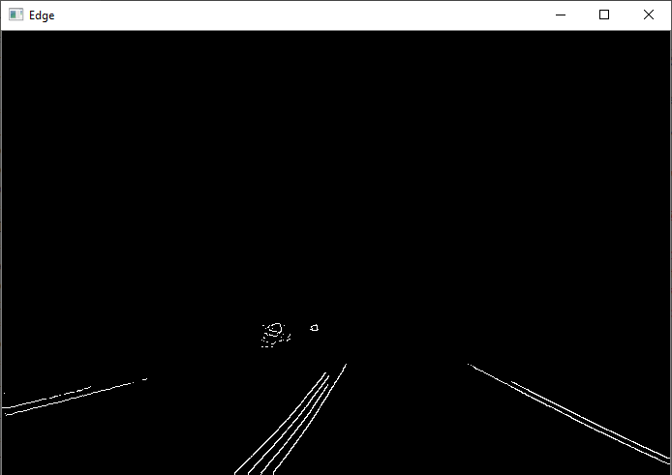
Figure – 10: Canny Edge Detection Example 1.
Figure – 11: Normal Image Example 2.
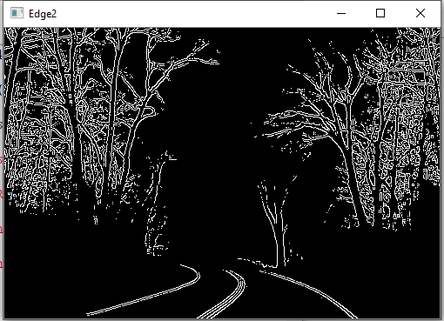
Figure – 12: Canny Edge Detection Example 2.
These images are feed to the proposed CNN model for the further prediction which will be given as the input to the auto-breaking system installed in the vehicles. The proposed CNN model is a sequential network of 3 convolutional layers with the 64, 128, 128 neurons at the respective layers. The first layer will get the image of the size (-1, 80, 80, 1) and the remaining layers will get the output of the previous layer as the input. For every Convolutional layer there is a Max-pooling layer which will help to search in the image pixels. And after the third convolutional layer the out will be given as the input to the series of flatten layers with 512, 128, 128 layers of the neurons which will help to flatten the network for the final output. The whole model is compiled with the Adan Optimizer for about 50 iterations or the 50 epochs for the better accuracy with the sparse categorical entropy as the loss function to measure the loss percentage. At last the model has achieved 96% accuracy and was tested on the real time data which has shown the accurate results in all the scenarios. The proposed model is ready to deploy on the real car for the passenger safety.

Results Discussion
The proposed CNN model which was used during the training is as shown in figure – 13. In which the specifications of the model that is the number of convolutional layers and dese layers along with the pooling layers and the number of neurons used for every layers is displayed in that figure. The result which was obtained by the proposed network is shown figure – 14. The figure contains details about the accuracy and loss of the CNN model. The model was trained with 50 epochs in which the loss was decreased up to 0% from 45 epochs and the accuracy reached 90% above from 35 epochs. At last the validation accuracy of the model has reached around 96%.

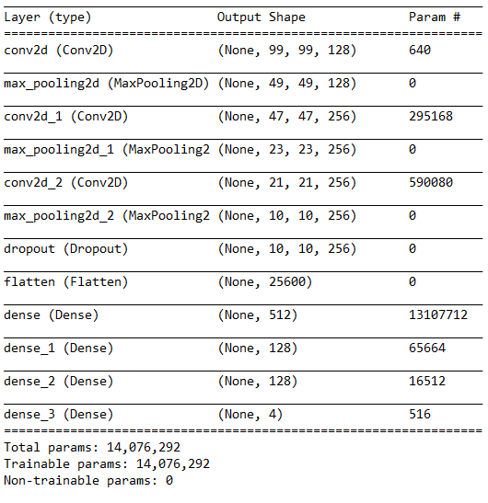
Figure – 13: Proposed CNN model
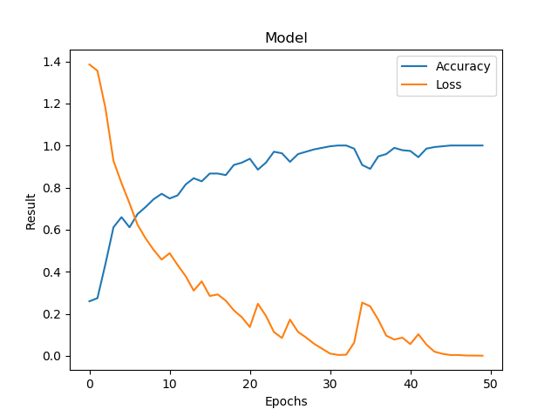
Figure – 14: Accuracy of the proposed CNN model.

Conclusion
In this paper the advantages of using the Infrared-Thermal cameras are discussed along with the usage of those cameras for the fog and night vision is implemented using a Deep Learning Convolutional Neural Network model. The training accuracy of the model was around 100% and as the validation accuracy of the model is 96% the model is ready for the deployment in the real time scenarios. As the accuracy of the model has reached a good level if it is deployed then it will help the people to be safe in all the times. And if the network is updated constantly with the new data that has been captured by the cameras in the vehicle to improve the accuracy of the model. At last after the constant updates the model will reach a pinnacle point at which the model will be perfect at all the weather conditions and at all road conditions.

References
- Nicolas Hautiere, Jean-Philippe Tarel, Jean Lavenant, Didier Aubert, “Automatic fog detection and estimation of visibility distance through use of an onboard camera”, Machine Vision and Applications (2006), Vol. 17(1), pp. 8–20.
- Manish Bhattarai, Manel Martinez-Ramon, “A Deep Learning Framework for Detection of Targets in Thermal Images to Improve Firefighting”, 2020, arXiv:1910.03617v2
- S. Bronte, L. M. Bergasa and P. F. Alcantarilla, "Fog detection system based on computer vision techniques," 2009 12th International IEEE Conference on Intelligent Transportation Systems, St. Louis, MO, 2009, pp. 1-6.
- R. Gallen, A. Cord, N. Hautière and D. Aubert, "Towards night fog detection through use of in-vehicle multipurpose cameras," 2011 IEEE Intelligent Vehicles Symposium (IV), Baden-Baden, 2011, pp. 399-404.
- Ankit Dilip Yawale, Prof. V. B. Raskar, “Pedestrian Detection by Video Processing using Thermal and Night Vision System Ankit Dilip Yawale”, International Research Journal of Engineering and Technology (IRJET), Volume: 03, Issue: 12, Dec -2016, pp. 852-858.
- Yingfeng Cai, Xiaoqiang Sun, Hai Wang, Long Chen, and Haobin Jiang, “Night-Time Vehicle Detection Algorithm Based on Visual Saliency and Deep Learning”, Journal of Sensors Volume 2016, Article ID 8046529, 7 pages.
- M. Raj and S. Chandan, "Pedestrian and Vehicle Detection Using Night-Vision Camera through CNN on Indian Roads," 2018 International Conference on Advances in Computing, Communication Control and Networking (ICACCCN), Greater Noida (UP), India, 2018, pp. 1136-1142.
- Chien, Jong-Chih et al. “Improving Night Time Driving Safety Using Vision-Based Classification Techniques.”, Sensors (Basel, Switzerland) vol. 17,10 2199. 24 Sep. 2017, doi:10.3390/s17102199.
- Park, Jisoo & Chen, Jingdao & Cho, Yong & Kang, Dae & Son, Byung. (2019). CNN-Based Person Detection Using Infrared Images for Night-Time Intrusion Warning Systems. Sensors (Basel, Switzerland). 20. 10.3390/s20010034.
- Varun Totakura, Mohana Krishna Janmanchi, Durganath Rajesh, M.I. Thariq Hussan, “Prediction Of Animal Vocal Emotions Using Convolutional Neural Network”, International Journal of Scientific & Technology Research, Volume 9, Issue 2, pp. 6007-6011.

